Caitlyn Jones
Prof. Yangyang Wang
MATH 40A: Intro to Applied Math
9 October 2024
Homework 2
- Information theory worksheets 1 and 2
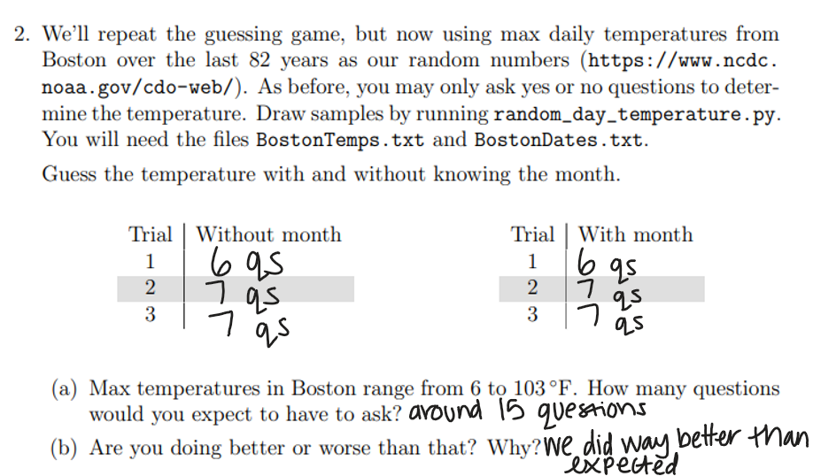
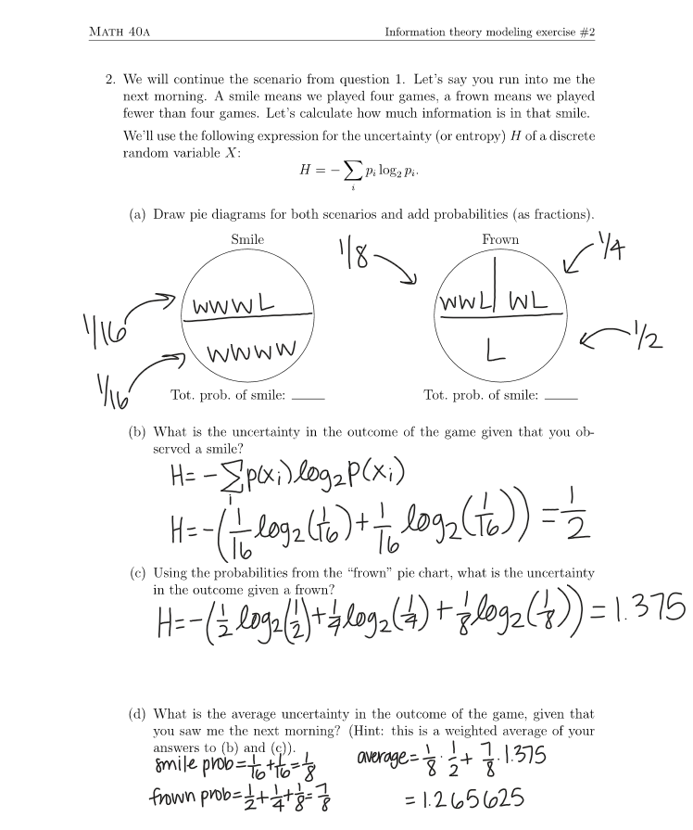

  - To calculate the Shannon entropy of each digit, I first created a function entropy(N) that will compute the entropy of a given N.
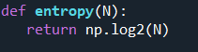

Then, I needed to determine what N will be for equation. For the first digit, N is 2 because the only two possible first digits are 0 and 1.
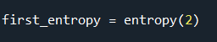


For the second digit, N is 5, as the second digit ranges from [0,4].


N is 10 for the third digit because N ranges from [0,10].
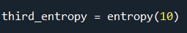

  - To calculate the sum of all three entropies, I created a variable entropy_sum that will compute the sum.

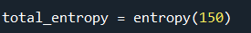
Then I calculated total_entropy.


The sum of entropies is different from the total entropy because there are restrictions placed on the second two digits if the first digit is a 0 versus if the first digit is a 1. However, total_entropy represents the randomness that takes place in selecting a number from the 150 different possibilities, which is why this number is greater than entropy_sum. These differences occur because entropy_sum has restrictions in place while total_entropy does not.

  - To inspect the 100 most common word pairs in the English language, I first had to read in the four given text files which contain the words, the indices of the common pairs, and the frequencies of the common pairs.
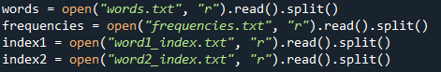

Then, I created variable frequency that will track the index of the frequency of the word pairs. Next, I created variable word_pairs that will hold the word pairs based off their corresponding word and index from the various text files.
From there, I was able to print the 100 most common word pairs.
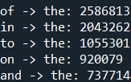
For the sake of space, I will not put all 100 pairs, but here are the first 5.

It makes sense that these words pairs are the 100 most common; however, the contractions are interesting because technically “n’t” is not a word, but the prefix with “n’t” is still among the 100 most common word pairs.
  - To write the 20 most common word pairs, I created a variable twenty_common that will hold the top 20 values from word_pairs.
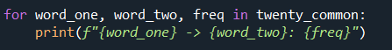
From there, I was able to print all 20 word pairs.

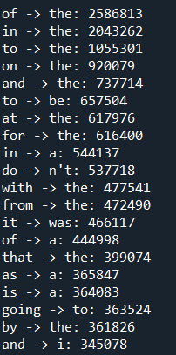

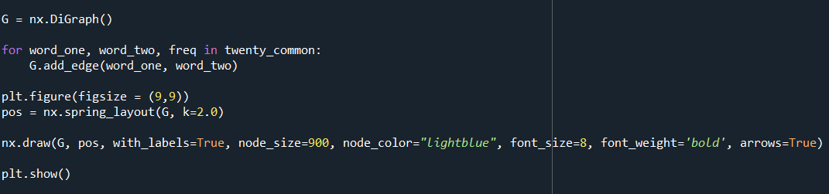
I used the built-in DiGraph() function to create the directed graph diagram that will have arrows from every first to in the pair to the second word in the pair.

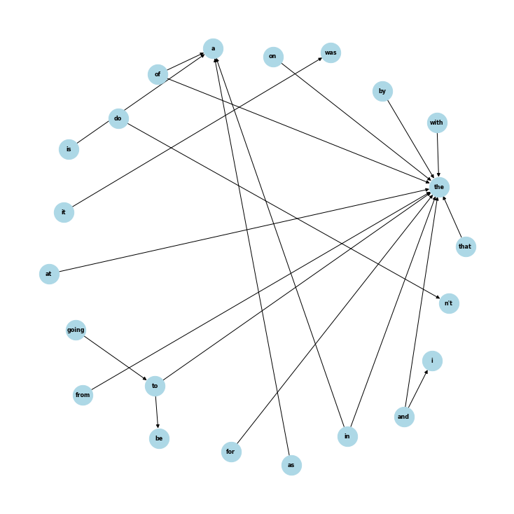
I was able to generate the longest word sequence by calling nx.dag.longest_word_path on this graph.
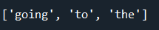

  - No, I cannot travel to every word through the arrows, as some of the pairs are incredibly common, but have no connection to the other common pairs. For example, “do n’t” is in the top 20 common pairs, yet I can only access this pair through “do”.
- We can derive $H\left(X,Y\right)=H\left(X | Y\right)+H\left(Y\right)$ given that
$$H(X,Y)=-\sum_{x,y}{p\left(x,y\right)logp(x,y)}$$By the definition of conditional probability, $p\left(x,y\right)=p\left(x | y\right)p\left(y\right)$.
$$H(X,Y)=-\sum_{x,y}{p\left(x,y\right)\log\left(p\left(x | y\right)p\left(y\right)\right)}$$
By logarithmic properties, we can rewrite this equation.
$$H(X,Y)=-\sum_{x,y}{p\left(x,y\right)\left(log(p\left(x | y\right)+logp\left(y\right)\right)}$$
Using distributive properties, we can expand this equation.
$$H(X,Y)=-\sum_{x,y}{p\left(x,y\right)logp\left(x | y\right)}+-\sum_{x,y}{p\left(x,y\right)logp(y)}$$
We can recognize the first equation as $H\left(X | Y\right)$.
$$H(X,Y)=H\left(X | Y\right)+-\sum_{x,y}{p\left(x,y\right)logp(y)}$$
Since $logp(y)$ does not depend on $x$, we can factor it out.
$$H(X,Y)=H\left(X | Y\right)+-\sum_{y}{p\left(y\right)logp(y)}$$
Now, we can recognize the second equation as $H\left(Y\right)$.
$H(X,Y)=H\left(X | Y\right)+H\left(Y\right)$ ∎

- Given $p_{0}=p_{1}=\frac{1}{2}$ and the equation
$$H(X)=-\sum_{i}{p\left(x_{i}\right)\log_{2}p(x_{i})}$$
We can assume, that for two symbols,
$$H(X)=-(\frac{1}{2}\log_{2}\frac{1}{2}+\frac{1}{2}\log_{2}\frac{1}{2})$$
$$H(X)=-(\frac{1}{2}(-1)+\frac{1}{2}(-1)$$
$$H\left(X\right)=-\left(-1\right)$$
$$H(X)=1$$
From here, we can compute
$I\left(X;Y\right)=H\left(X\right)-H(Y|X)$
$$I\left(X;Y\right)=1-1$$
$$I\left(X;Y\right)=0$$
Therefore, the rate of transmission is 0.

